**Systems Analysis and Design**

**Phase 1**

**D23128292**

**Saba Manjgaladze**

**Table of Contents**

1 General Project Information 1

1.1 Introduction 1

1.2 Research 1

1.3 Scope Statement 3

2 Use Case Diagram 5

3 Non-functional requirements 7

4 Activity Diagram 9

# General Project Information

## Introduction

## The purpose of this paper is to cover a project that revolves around a food delivery app similar to Deliveroo, Just Eat, Uber Eats, Seamless, or just about any other app that offers similar service. The name of our app is **Gus Station**, which I derived from the word “Degustation”, which in simpler terms means tasting of various different kinds of foods. To build a more adequate, and a successful business model for my app, I chose to follow the recipe that is known to work, and chose to go by a similar model to that of Glovo, which is an app that was launched in Spain in 2014, and offers a delivery service of any product, not just limited to food from restaurants. I chose this app as a blueprint for mine as I am very familiar with it, I have used it countless times before, and simply like the way it functions. But for the simplicity of the project my main emphasis remained on food delivery from restaurants, rather than a combined delivery service of supermarket goods, and restaurant foods. In the next several sections I will go in depth about what exactly Gus Station offers, will provide some research data regarding both out blueprint; Glovo, as well as our competitors in Ireland. I will also provide use case diagram, a narrative attached to it, along with an activity diagram. And any relevant information associated with operating our app.

## Research

After a thorough research I have come to find that there are three major food delivery services in Ireland that would be our biggest competitors on the market. Although, there are also similar companies that offer delivery services, their focus is not restaurant food delivery like it is in our case, but rather a supermarket produce delivery service. Thus, these companies would not be considered as our direct competitors. The three major competitors in our case would be **Deliveroo**, **Just Eat**, and **Uber Eats**. (*Deliveroo*, n.d.; *Order Food Delivery & Takeaway from Local Restaurants | Just Eat*, n.d.; *Uber Eats | Food Delivery and Takeaway | Order Online from Restaurants near You*, n.d.)

Upon examining all three competitors it has become apparent that all three of them have basically identical characteristics, after all these apps revolve around the same thing, and that is to order food from the comfort of your home. However, there are some smaller tweaks that each company has made to their business plan all of which have made each of them different. Most of these differences are at a microeconomic level. For instance, Just Eat has roughly 14% commission charge (average) on each meal ordered (“How Much Are You Losing through Using Just Eat?,” n.d.), whereas Uber Eats has a commission rate that starts at 15%, (Dzierlatka, 2023), and Deliveroo has an average commission fee ranging from 25% to 35% (*Deliverect GB | Deliveroo 101*, n.d.). These commission rates are almost always based on which plan a restaurant has selected when singing an agreement with the food delivery service. Usually these commission rates are upwards of 25% if restaurants decide to sign exclusive deals with these food delivery companies. For such a hefty commission rate, restaurants then benefit from more aggressive marketing carried out by the delivery companies which might include practices such as: putting restaurants under “featured” category, displaying banners with text “only on “___(the company name)___”, as well as online ads. Other than these small differences, the biggest difference all of these companies have are in terms of marketing, which is not really surprising considering that these companies vary in size, and some also have parent companies that have greater financial power than the others (e.g. Uber Eats is owned by Uber Technologies – one of the largest companies in the world in terms of market cap)(*Companies Ranked by Market Cap - CompaniesMarketCap.Com*, n.d.).

Nonetheless, our app Gus Station will follow the example of the aforementioned Glovo, as Glovo is an app that is used in 25 countries, 1,300 cities, has 61,000 couriers, 170,000 local stores, and employs 4,200 people, making it a recent success story. (*Home - Glovo Corporate Site*, n.d.) Additionally, Glovo offers delivery services that range from restaurant foods all the way to pharmaceutical products, this feature is something that a food delivery company entering the market could also adopt post-expansion phase to further grow the company.

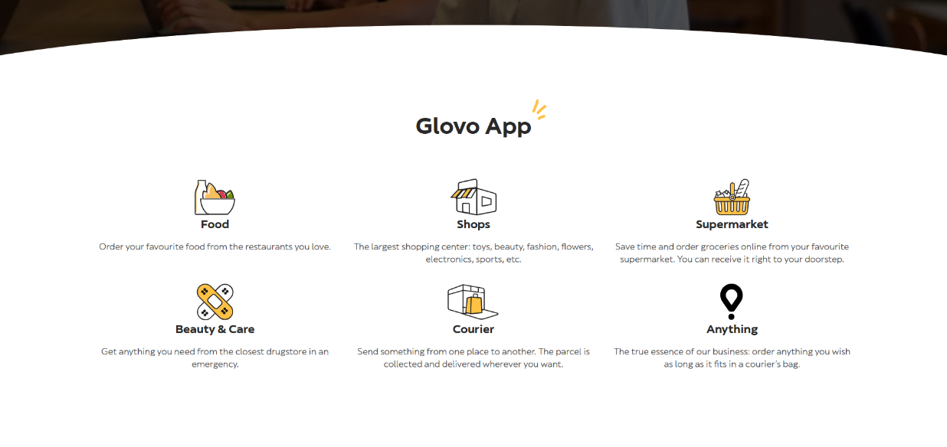 The Glovo business model is illustrated below:

So, all of this begs the question of: what is our goal. And the goal is simple, it is to offer people a service that will allow them to order food from the comfort of their home, work, or any place with an official address, and to have food delivered to them in a timely and a convenient fashion, all while keeping the members data including payment methods private via data encryption.

Much of the framework will remain the same in terms of numbers (e.g. commission rate), but the main differences that will set us apart will be branding, and marketing. Everything else regarding the question around the functionality of the app, what steps need to be taken chronologically to use the app properly, and how the whole system will operate overall will be answered more in detail in the next following sections.

## Scope Statement

[Outline clearly the major scope based on your research.

Briefly outline any assumptions/constraints you are making in relation to this project. E.g. third-party providers etc. This may be related to what you chose not to include as well as issues related to the nature of the product being developed e.g. focusing solely on addressing personal customers not business to business.]

Firstly, what needs to be addressed in our business model is the legal framework for data protection. Thus, any kind of service that Gus Station may offer must be within the legal framework set forth by Data Protection and the General Data Protection Regulation (GDPR) of Ireland. (*Data Protection and the General Data Protection Regulation (GDPR)*, n.d.).

Going forward, what the app must offer is a simple interface that allows users to be delivered food to the indicated premises when making an order. Seems pretty straightforward, but there are some pre-requisites to being able to do that. When downloading the app, or simply accessing our website a user must have freedom to browse through our partnered restaurants, as well as their menus. If a user decides that s/he wants to make an order, the user must go through the registration process. The registration process will require the name of the user (at least the first name), the user’s cell-phone number, personal e-mail address, and the physical address to which the user would like the food to be delivered. After filling out the form, the user will receive an email with a code to confirm his/her compliance with rules and regulations of the app/website, as well as to confirm that it is actually him/her trying to set up an account.

After the confirmation process is over with, the newly registered member will be able to proceed to the checkout where the member will be prompted to enter credit card information of the card s/he would like to pay with. The transaction will then be processed by a 3rd party service to guarantee the safety surrounding accessibility to the credit card information from our end. And regardless of the outcome of the transaction, whether it successfully goes through, or fails the member will receive an email. In case of a successful transaction the member will automatically receive an email of a receipt, whereas in case the transaction fails the member will be notified about the matter along with the reason why the transaction failed (e.g. “bank declined the transaction”).

The member will be able to utilise the app 24/7 as long as there are restaurants open, and as long as there are couriers to deliver them food. Speaking of delivery, if a delivery ends up being late, or a restaurant is forced to cancel an order after the time limit that is given to the restaurant to process the order, the member will not be charged for the food, and will also receive credits on the app to compensate for the inconvenience. Also the app will have a built in live chat feature that lets members connect to staff in case there are any mishaps, or complaints. If the food is damaged, if a member receives a wrong order, or a member believes that the food has been opened, and altered in any way, they should reach out to customer service via live chat and send a proof, which will be followed by either partial or a full refund depending on the case. Members can also rate the food that they ordered after they eat it, as well as couriers who brought them the food. These ratings will be entered into our system which will enter into the overall rating of a restaurant. The more positive ratings, a restaurant receives, higher they will be ranked within the app and on the website, allowing them to benefit from better traction, and marketing. As far as the couriers go, if a courier receives a bad rating, the courier will no longer be able to deliver to the person who gave them a bad rating, and must avoid frequently receiving bad ratings as too many instances will lead them to having their work contract terminated. All ratings/comments will be kept anonymous.

Members will also be able to benefit from sales, and offers on the app, or the website, and can even apply to become a courier for the company. The application process to do so will ask the aspiring courier for documents such as I.D, drivers licence, work permit, credit card information, and several other relevant documents. After all of the required files are submitted, the Gus Station team will review the application and reach out to the applicant within 7 – 10 business days via email whether the applicant gets accepted or not, and will be given further instructions via email in terms of what steps to take next.

After being accepted as a courier, and after receiving equipment from the Gus Station team, the courier will be able to start delivering food from various restaurants to members. Couriers will have salaries, and will be paid based on the amount of deliveries they make. Additionally, couriers will be free to receive tips from members, the tips can come in forms of cash payment as well as credit card transactions (while going through a checkout, members can indicate tip amount that will be put on hold on their bank account until the delivery is finalised, and after it is finalised will automatically be transferred over to couriers account). In addition to delivery privileges, couriers will also be able to receive all of the member privileges along with discounts on food.

And finally, restaurant owners will be able to utilise the app or a website to apply as a restaurant, after which the Gus Station team will get in touch with the owner to request the paperwork that provides evidence of the owner actually owning or renting the property, and various other documents such as their I.D, company credit card details, etc. After registering as a restaurant, the restaurant will be able to sell their food. The restaurant privileges will only include ability to: accept orders, decline orders, receive ratings/get ranked, and receive emails after each order is taken out by a courier (email notifications can be turned off at any time, by any entity). Additionally, restaurants will be free to negotiate different types of contracts, including exclusive deals which will mean that they will only partner with the Gus Station, and no other delivery service for a greater commission fee, while in return they will receive greater marketing on the expense of Gus Station.

# Use Case Diagram

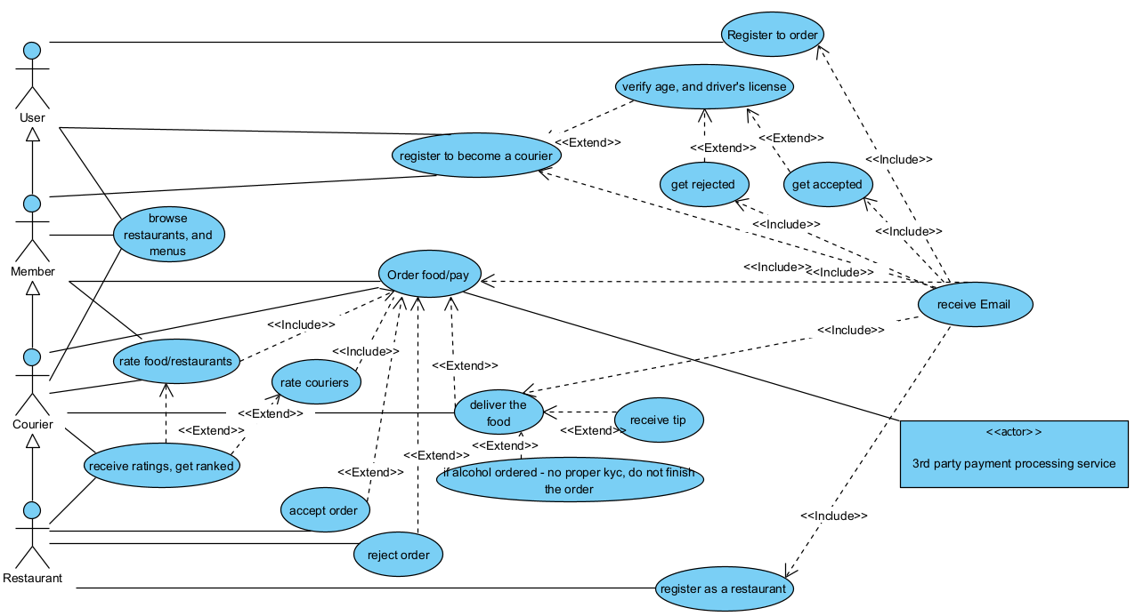

**Use Case Narrative**

Our food delivery app Gus Station helps connect users, members, couriers, and restaurants all within the app.

* **Users** – are free to browse restaurants, and the restaurant menus, as well as register to become a courier for the company, or simply register to be able to order food and use the delivery services.
  + Upon registering as a member the user will have to provide their details such as name, surname, phone number, address, as well as credit card information to process orders. And after successfully registering they will be sent a confirmation email.
  + Upon registering as a courier the user will also be asked to provide personal details, along with credit card information for payment, KYC using their I.D cards to determine if the person is eligible to work (18 years or older), as well as the copy of their driver’s license.
    - After submitting the requested files, the files will be processed by the HR team to determine if the user is qualified to become a courier for the company. And, in either case whether the user gets accepted or not, the user will be sent an email with further instructions. If the user gets accepted, the user will automatically also receive the member privileges.
* **Members** – much like users, members can browse restaurants, and their menus, as well as register to become a courier having gone through the same application process as mentioned previously. The main privilege that the members receive is to order food to be delivered to their address, as well as rate the dish they ordered which will be later used by the algorithm to calculate the overall rating of the restaurant, and rate the courier who delivered their food (all ratings will be anonymous).
  + After a member selects the food they would like to order, they will go through a payment process where they select the payment method (either their credit card that is already indicated, or freedom to add another option), where they will be met by the exact cost of their order including VAT, delivery fee, and the food itself. On the same screen the member will have an option to leave tip for the courier using their cashless payment method, or to leave the field blank and tip the courier in cash (tips are optional of course).
  + After going through the checkout screen, a payment processing will begin which will likely take up to a minute and the user will be sent an email regarding the status of their order. If the payment is successful the member will receive an email in form of a receipt, and if the payment is declined the member will receive an email notifying them about the matter.
* **Couriers** – given that couriers automatically receive member privileges after being accepted for the job, they will also benefit from being able to order food, and rate the ordered food, and their colleagues as well. Couriers will obviously also have an ability to fulfil their duties or in other words deliver food to customers, receive tips, as well as leave an order unfinished if an order includes an age restricted product (e.g. alcohol), and the person who ordered this product either already sounds clearly under the influence while speaking to a courier on the phone, or is unable to prove (by showing their I.D) that they are of legal age.
  + Upon completing a delivery, courier will use the app to declare a delivery as either fulfilled or abandoned (with reason stated), and will receive an email with the summary of their delivery.
  + Couriers will also receive ratings from customers, and if a customer leaves a courier a bad rating the respective courier will no longer be assigned to deliver food to the person who gave a low rating. Couriers also must avoid receiving low ratings as too many instances of being rated poorly can lead to them having to leave their duties.
* **Restaurants** – can register as restaurants by going through a registration process either on the app or by using the website. Much like the registration process for other entities, this form of registration will also require a proper KYC, and an email address for receiving receipts of deliveries, and other updates.
  + The restaurants will be able to sell their food by using the platform, receive ratings, and an option to either accept an order, or decline an order.
    - The restaurants will be free to decline orders whenever they have a high demand and can no longer cater to customers due to time constraint, or any form of hindering factors that will not allow a restaurant to fulfil an order.
    - Unlike couriers and members, restaurants will not be able to rate other restaurants, or couriers to keep the platform unbiased.
* **3rd party payment processing service** – will handle transactions to keep the bank information safe, and private.

# Non-functional requirements

* **Security**
  + **Legal** - First and foremost, our app/website must comply with Data Protection and the General Data Protection Regulations of Ireland.
  + **Confidentiality -** The data must be encrypted, and users should feel safe using our services every time.
  + **Safety -** Payments must be processed via a third party service.
* **Reliability**
  + **Availability** - Our services must be reliable, and have and be up and operating at least 99.9% of time. Given that peak hours for usage of similar apps to ours is 11:30 AM to 2:00 PM and 5:30 PM to 9:00 PM on weekdays, and the busiest hours being on weekends in particular on Fridays and Saturdays 6:00PM – 9:00PM. So with the peak hours of around 6 hours per day (rough estimate)(*Deliveroo | The Deliveroo Riders Website*, n.d.; Zhang, 2024), and majority of restaurants being closed after 2:00 AM, we have some “wiggle room” and 8.75 hours of downtime per year should not be very problematic.
* **Performance Efficiency**
  + **Response Time/Speed –** after each click, our page/app should not take more than two 3 seconds to load as long as the internet connection is strong, and stable. Additionally, payment processing should take 1 minute at most, and should not exceed a minute.
* **Portability**
  + The website must be optimized for all major browsers including: Chrome, Safari, Edge, Firefox, Opera, etc. And should run without any problems on Mac OS, Windows, and Linux. The app must run on IOS, and on Android devices (targeted devices).
  + Language – both, the app and the website must have options between English, French, Spanish, Arabic, and Mandarin interfaces.
* **Usability**
  + **Accessibility –** our website, and our app must both comply with Web Content Accessibility Guidelines 2.0. (Initiative (WAI), n.d.)
    - Additionally, both the website and the app must cater to various physical, and cognitive disabilities including: color blindness, autism, epilepsy, and several other cognitive disabilities. For physical disabilities the interface must have at least “one handed” mode, and simplified menus for ease of access.
* **Compatibility**
  + **System Requirements and Memory –** Gus Station app will be 25MB’s to download, but will require around 120MB’s of memory, as the app will store some data. The required OS will be: Android 6 and up for Android devices, and IOS 13.6 and above for IOS devices.
* **Maintainability**
  + **Frequency of Revisions –** Our app must be updated at least once a month, to avoid any complications with bugs. If any serious bug arises that hinders usage of our app, the issue must be addressed immediately, and a new update must be sent out at the earliest convenience.
* **Technical Environment** 
  + The system must be build using Java, and the code must be accessible through repositories for ease of maintainability.

# Activity Diagram

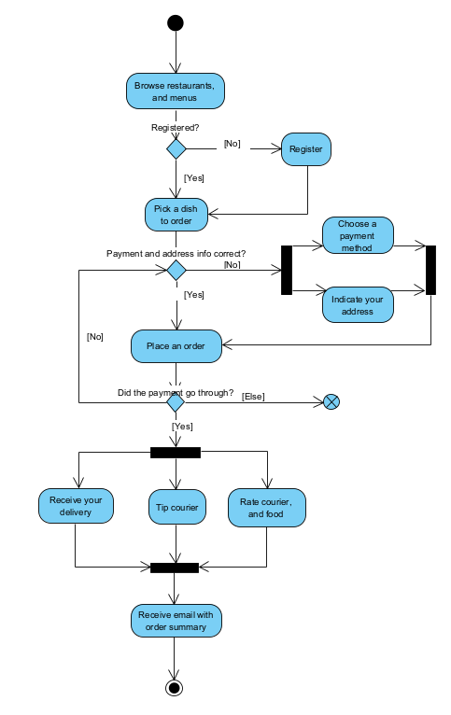

**References**

*Companies ranked by Market Cap—CompaniesMarketCap.com*. (n.d.). Retrieved February 28, 2024, from https://companiesmarketcap.com/

*Data Protection and the General Data Protection Regulation (GDPR)*. (n.d.). Retrieved February 29, 2024, from https://enterprise.gov.ie/en/who-we-are/corporate-information/data-protection/data-protection.html

*Deliverect GB | Deliveroo 101: The Essential Guide For Restaurants (2023)*. (n.d.). Deliverect. Retrieved February 24, 2024, from https://www.deliverect.com/en-gb/blog/online-food-delivery/deliveroo-101-the-essential-guide-for-restaurants

*Deliveroo*. (n.d.). Retrieved February 28, 2024, from https://deliveroo.ie/

*Deliveroo | The Deliveroo Riders Website*. (n.d.). Retrieved March 1, 2024, from https://riders.deliveroo.ie/en/support/orders/completing-orders-during-our-busy-times-helps-you-to

Dzierlatka, J. (2023, January 31). *Uber Eats Commission: How Much Does Uber Eats Charge Restaurants?* UpMenu. https://www.upmenu.com/blog/uber-eats-commission/

*Home—Glovo Corporate Site*. (n.d.). Retrieved February 28, 2024, from https://about.glovoapp.com//

How much are you losing through using Just Eat? (n.d.). *AppInstitute*. Retrieved February 24, 2024, from https://appinstitute.com/just-eat-commission/

Initiative (WAI), W. W. A. (n.d.). *WCAG 2 Overview*. Web Accessibility Initiative (WAI). Retrieved March 1, 2024, from https://www.w3.org/WAI/standards-guidelines/wcag/

*Order Food Delivery & Takeaway from Local Restaurants | Just Eat*. (n.d.). Retrieved February 28, 2024, from https://www.just-eat.ie/?&adj_tracker=84l7irb&adj_campaign=12816460944&gad_source=1&gclid=CjwKCAiA0PuuBhBsEiwAS7fsNdlBWg8kqzFmxiOOO_-M_NZNR23y1AF_f62KfWt3ZDedF2DA5gMvSRoCjgUQAvD_BwE&gclsrc=aw.ds

*Uber Eats | Food delivery and takeaway | Order online from restaurants near you*. (n.d.). Retrieved February 28, 2024, from https://www.ubereats.com/ie

Zhang, P. (2024, January 19). Best Times to Deliver For Uber Eats (2024 Guide). *TripLog*. https://triplogmileage.com/rideshare/best-time-to-do-uber-eats/